### **Project 9：Steam Sensor**

**Description**

This is a commonly used water level sensor. The principle is to detect the amount of water through the exposed printed parallel lines on the circuit board. The more water, the more wires are connected. As the conductive contact area increases, the output voltage will gradually increase. The water level sensor can be used as a rain detector switch. When the humidity on the sensor surface increases sharply, the output voltage will increase.

The sensor is compatible with various microcontroller control boards, such as Arduino series microcontrollers. When using, we provide a guide for operating the water level sensor and Arduino control board. Connect the signal end of the sensor to the analog port of the microcontroller, sense the change of the analog value, and display the corresponding analog value on the serial monitor.

Note: The connection part is not waterproof, please do not immerse it in water.

**Specifications:**

* Working voltage: DC 3.3-5V
* Working current: <20mA
* Operating temperature range: -10 ℃ ～ ＋ 70 ℃;
* Control signal: analog signal output
* Interface: 2.54mm 3pin pin interface
* Size: 35 * 20 * 8mm
* Weight: 2.2g
* S: signal output
* +: Power supply (VCC)
* -: Ground (GND)

**Equipment：**

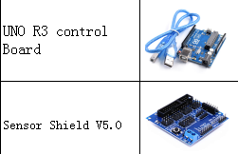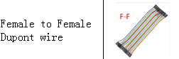

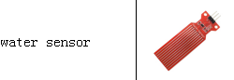

**Equipment：**

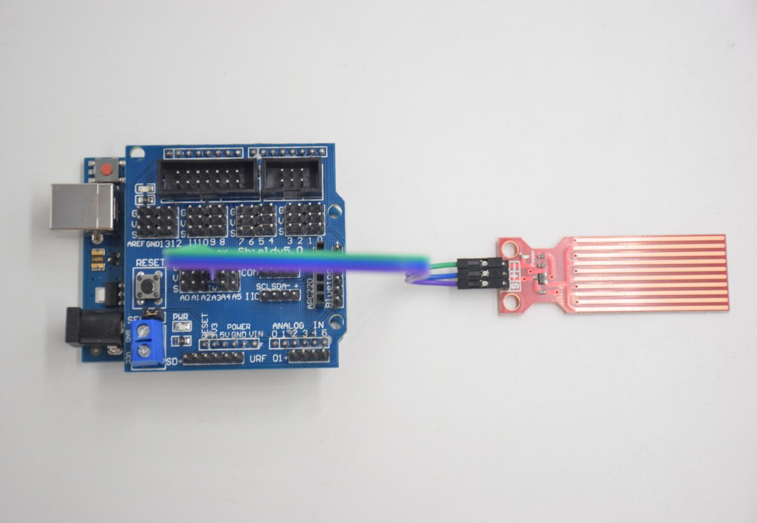

**Water level module:**

**- -- GND**

**+ -- 5V**

**S -- A3**

**Test Code：**

**void setup()**

**{**

**Serial.begin(9600); //open serial port, and set baud rate at 9600bps**

**}**

**void loop()**

**{**

**int val;**

**val=analogRead(3); //plug vapor sensor into analog port 3**

**Serial.print("Moisture is ");**

**Serial.println(val,DEC); //read analog value through serial port printed**

**delay(100); //delay 100ms**

**}**

**Test Result：**

